

**Microsoft Azure Machine Learning**

**INSTRUCTOR INFORMATION**



Loy Vanich

084 007 5544

Line ID: laployv

laploy@gmaill.com

www.laploy.com

**TIME FRAME**

* Course duration
* Start time
* Coffee break
* Lunch break
* Course end

**COURSE OUTLINE**

* Introduction to Azure ML
* Introduction to Data Science
* First Experiment
* Titanic
* ML Evaluation
* ML Algorithm

Course Github page

https://github.com/laploy/Azure-ML-Express

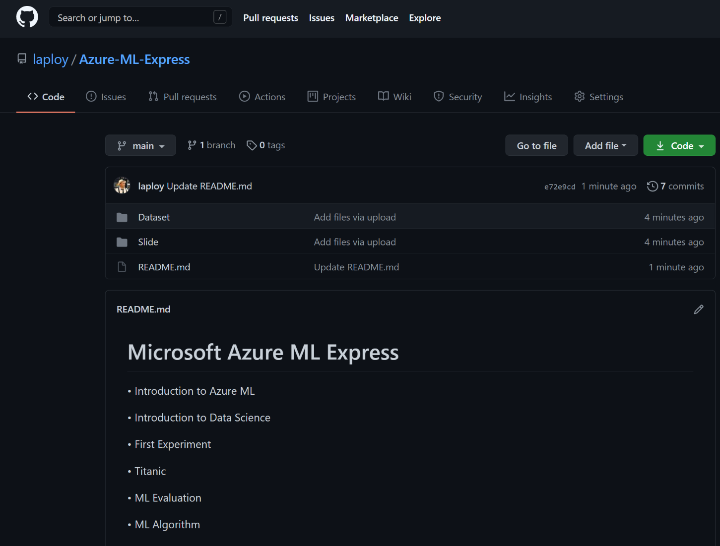

Microsoft Azure Machine Learning Studio landing page

studio.azureml.net

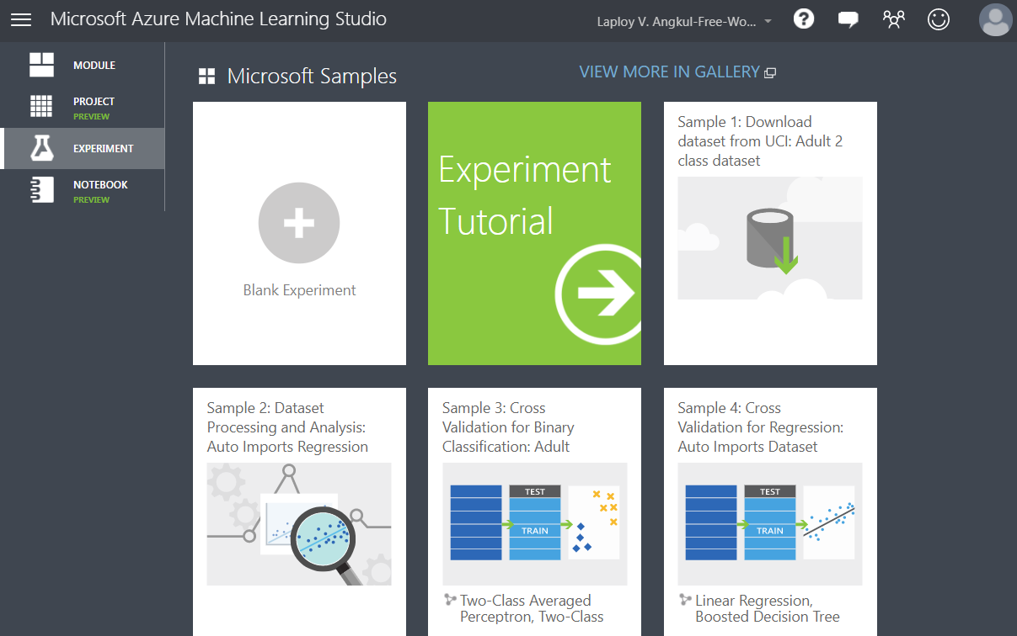

Microsoft Azure New Portal

https://portal.azure.com/

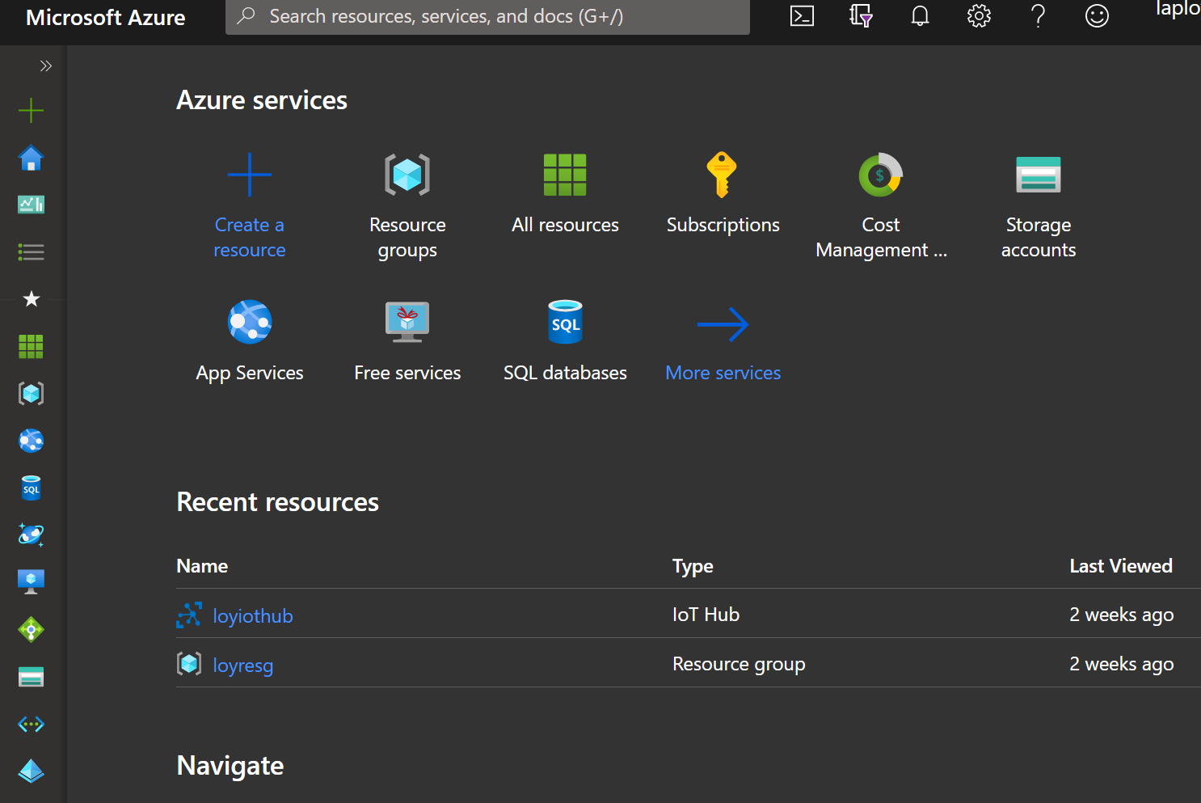

Line Group

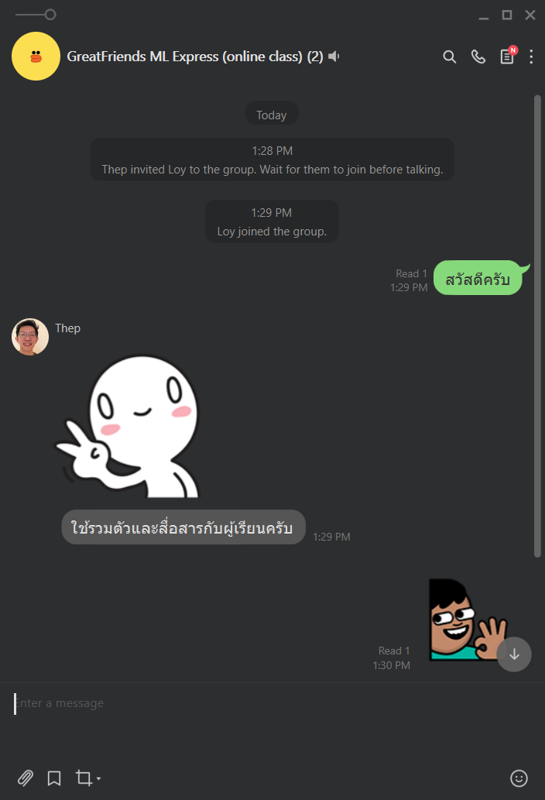

Evaluation Form

Evaluation form

<https://bit.ly/gfbiz-eval>